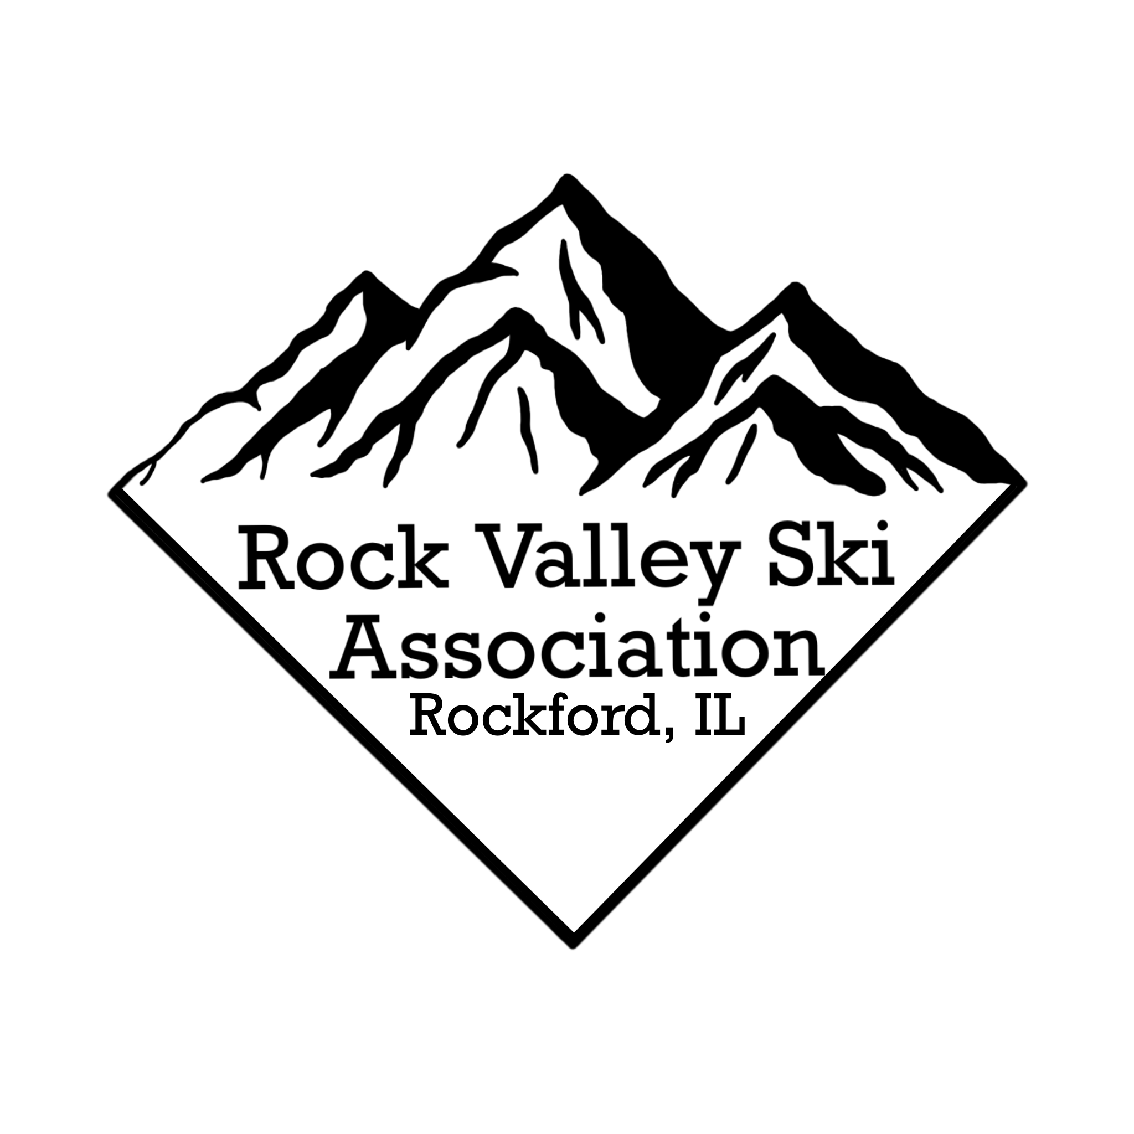
Rock Valley Ski Association Trip Agreement Contract
___ Snowbird - Snowbird, Utah - March 23 - 30, 2024
___ Jackson Hole - , 2024 Jackson Hole WY March 3-10 2024
Name: |  | Legal Name:
AS APPEARS 0N REAL ID OR PASSPORT: FIRST, MIDDLE, LAST
Address: |  | Phone:

City: |  | State: |  | Zip: |  | Email:

Birthdate: |  | Gender:
TSA REQUIREMENT AS APPEARS-REAL ID OR PASSPORT
Emergency Contact: |  | Phone:
REGISTRATION, CANCELATION, TERMS AND REGULATIONS
Reservation for a club trip is a privilege and priority will be given to current club members. This completed “Trip Agreement Contract” must be submitted with the appropriate deposit to the trip leader or designee. RVSA reserves the right to decline acceptance of a trip application at any time, due to, but not limited to, the past inappropriate behavior of the applicant. Applications will be reviewed for acceptance. Denial of application will be determined by a simple majority vote of the RVSA Board.
RVSA reserves the right to change itinerary, cancel or amend the trip, change the mode of transportation if the RVSA Board deems it necessary for reasons that may include, but are not limited to, weather, conditions, labor strike, safety or other unforeseen circumstances.
RVSA and its officers and members shall not be held responsible or liable for any accident, injury, damage, or loss incurred by neglect or default of any company or person engaged in conveying a trip, such as, but not limited to, air, motor bus, or other reserved form of transportation.
RVSA and its officers and members shall not be held responsible or liable for any injury, damage, or loss incurred by neglect or default of any company or person engaged on occasion by hotel/resort proprietor(s).
RVSA is not responsible for any loss of time due to illness, snow conditions, or pandemic. Applicants are encouraged and responsible for their own trip insurance. Applicants are responsible for making sure they have proper identification on trips and their documents are up to date.
Applicants are responsible for their own health insurance and to make sure it covers international destinations (if applicable). RVSA is not responsible for any personal injury, damage, or loss incurred or harm to others by a trip participant on RVSA trips.
Applicants are responsible and required to submit a copy of their current, valid passport for international trips. Applicants are responsible to research and ensure they are eligible to enter Canada or other international destinations.
RVSA reserves the right to withdraw a trip for non-fulfillment or the safety and well being of its attendees. Participants are subject to cancellation fees (up to the full trip amount) if they cannot provide a substitute traveler in their place.
I HAVE READ AND AGREE TO TERMS STATED AND REFERRED ON THIS DOCUMENT.

Signature: |  | Date:

IKON Pass # ______________________ United Airlines Mileage # _______________________ Roommate Preference ________________________
TSA # __________________

